Tool: GBV Mapping Across a Project and Applied to a Value Chain Assessment

Making a gender-sensitive value chain map
This tool aims to identify instances of GBV along the value chain. Through a series of simple steps, it is possible to obtain a graphic representation of the value chain that shows how GBV may occur in each node and interact with other factors in the core and extended value chain (e.g., input or service providers, financial institutions and buyers). The tool was developed as a participatory analytical tool to be applied in consultation with value chain actors and key informants (both women and men). It requires basic facilitation skills and materials (flipcharts, colored cards, markers) and can be used to design the value chain map through various phases of group work or to summarize information the project gathers through other methods. This tool may be paired with Annex 4A of the Toolkit to Address Gender-Based Violence in Agriculture and Market Systems Development on GBV safety mapping.
This tool was adapted from the FAO’s Developing gender-sensitive value chains – Guidelines for practitioners and originally included in the Agri-ProFocus publication, Gender in value chains – Practical toolkit and USAID’s Promoting Gender Equitable Opportunities in Agricultural Value Chains Handbook.
The mapping exercise can be structured into three main steps:
STEP 1: Map the product flow and the value chain actors in the core value chain
Participants in the mapping exercise are asked to:
  - Define the target area and the product/value chain to be mapped.
  - Identify the different value chain nodes, write each node on a card, and put the cards on the board in a logical order (e.g., from production to consumption). Draw the links that connect all nodes (e.g., production, aggregation, processing, and distribution).
  - On a different set of cards, list the different actors operating in the value chain. They can include small producers, large/industrial producers, small-scale/artisanal processing units, wholesalers, and small retailers.
  - Draw lines between actors to indicate how the product flows along the chain. What is the volume of product handled by each actor? Where is value addition taking place?
  - It is important to remind the participants to think about both the formal and informal value chain.
  - Identify the end market (e.g., local/export market).
  - Indicate the percentage/proportion of women and men for each actor/activity mapped. Identify the actors who contract hired labor and determine if the hired workers are men or women. Identify the businesses that are owned by women and men.
  - Differences can be highlighted using symbols of different colors and size.
  - Depending on the scope of the analysis, it may be worthwhile to further disaggregate the analysis, for example, by taking age into consideration. This helps visualize whether the chain involves young people or provides new opportunities to engage them.
  - Highlight where women provide unpaid family labor with little or no control over the income generated.
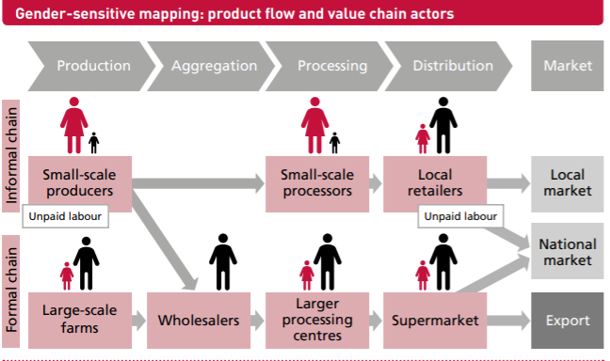
Source: FAO Developing gender-sensitive value chains – Guidelines for practitioners, 2018.
STEP 2: Map the support services in the extended value chain (input providers, financial and non-financial services)
At this step, participants in the mapping exercise are asked to:
  - On cards of different colors, list the support services available for the identified actors.
  - These can cover input and service providers, including extension, certification, financial, and business development services. Also consider transport and market information as fundamental to value chain operations.
  - Investigate the availability of complementary services that might help with their household responsibilities (e.g., childcare services in the workplace, reproductive health services).
  - On separate cards, identify the opportunities and constraints that women face in accessing and benefiting from these support services. Key questions to stimulate discussion and facilitate the analysis may include:
  - What percentage of women and men have access to these services? Indicate this on the card using different symbols/colors.
  - Do women face specific or additional challenges compared to men in accessing these services? If so, list them on separate cards (marking them with a “–“ sign).
  - Are services designed with women’s specific needs and interests in mind (e.g., household obligations, time constraints, limited mobility, lack of collateral)? Are there specific measures to reach them and respond to their needs? If so, list them on separate cards (marking them with a “+” sign).
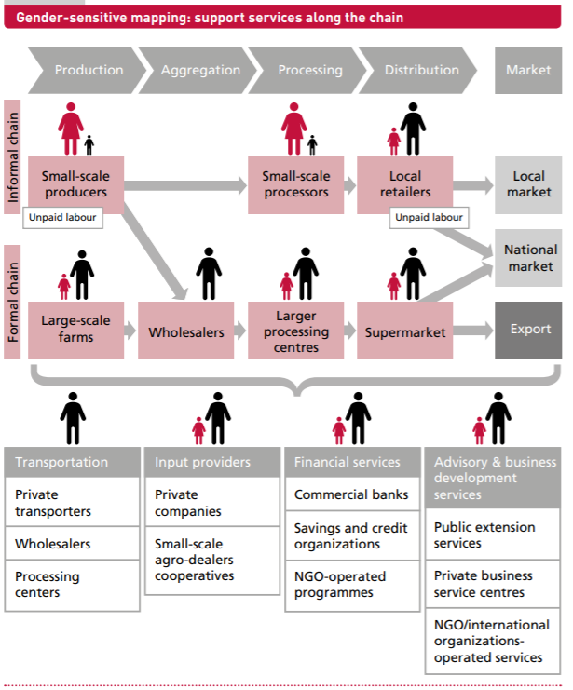
Source: FAO Developing gender-sensitive value chains – Guidelines for practitioners, 2018.
STEP 3: Identify the underlying gender-related factors in the enabling environment that facilitate or hinder women’s participation and benefits
At this step, participants in the mapping exercise are asked to:
  - Examine the broader environment and identify the gender-related factors that affect the role and position of women and men of different ages and socioeconomic status in the value chain. These factors relate to areas of gender inequalities (see Chapter 2 of the Toolkit to Address Gender-Based Violence in Agriculture and Market Systems Development) such as: control over household decision-making; access and control over productive assets; social norms and expectations regarding the gender division of labor within the household and stereotypes about women’s and men’s appropriate jobs, roles, and responsibilities; legal frameworks or customary rights regarding the ownership of land and other assets; public policies on employment or rural finance; consumer trends; certification standards; infrastructure in rural areas (e.g., for communication or transportation).
Key questions to facilitate the analysis at this step include:
- Do women and men have equal decision-making power over household and community activities, especially those related to agriculture and market systems development?
- Do women and men have equal access to productive resources, assets, and inputs (e.g., land, livestock, equipment, financial services)?
- How is labor distributed within the household? Do women’s household responsibilities (e.g., childrearing, food preparation) affect women’s or men’s time use and their capacity to engage in productive work?
- Do social norms affect women’s and men’s participation in the labor market? Do they influence how labor is distributed along the chain and in the different nodes?
- Do current policies and laws promote and protect women’s rights and opportunities?
Step 4. Identify where and how GBV-related risks intersect with the value chain
At this step, participants in the mapping exercise are asked to:
  - Refer to the graphic of GBV Across Market Systems Levels (Section 2 of the Toolkit to Address Gender-Based Violence in Agriculture and Market Systems Development) and Illustrative GBV Project Risks, By Value Chain Node (Annex 1 of the Toolkit) to consider the types of GBV that may intersect with different nodes and services along the value chain you have mapped.
  - For each of the key nodes and support services, identify the following; be sure to focus especially where there are currently greater gaps in women’s participation:
  - Where GBV may limit participation or benefit (use one symbol, such as an “!” in one color; consider using a greater number [such as !, !!, or !!!] to indicate the degree of impact)
  - Where project activities may potentially increase GBV risk (use the same symbol, such as an “!” in a different color; consider using a greater number [such as !, !!, or !!!] to indicate the degree of increased risk)
  - Where GBV is identified, use cards to summarize and add the following to the mapping:
  - Types of GBV
  - Key factors (e.g., places, time of day/season, type of relationships/interactions)
  - Any protective strategies identified
  - Particular groups with increased or distinct risks
Key questions to facilitate the analysis at this step include the following:
- In what ways may GBV be a barrier to women or other vulnerable groups’ ability to participate in or benefit from this node or services? What may help mitigate it?
- Are there particular aspects of this node or the way that services are provided that may unintentionally increase risks of GBV? What factors increase this potential risk, for whom, and in what circumstances? What strategies may offer protection?
- Also consider whether carrying out a safety mapping with related discussion questions (see Annex 4A of the Toolkit) may be helpful to explore GBV risks in more detail for specific nodes, services, or other identified project elements.

