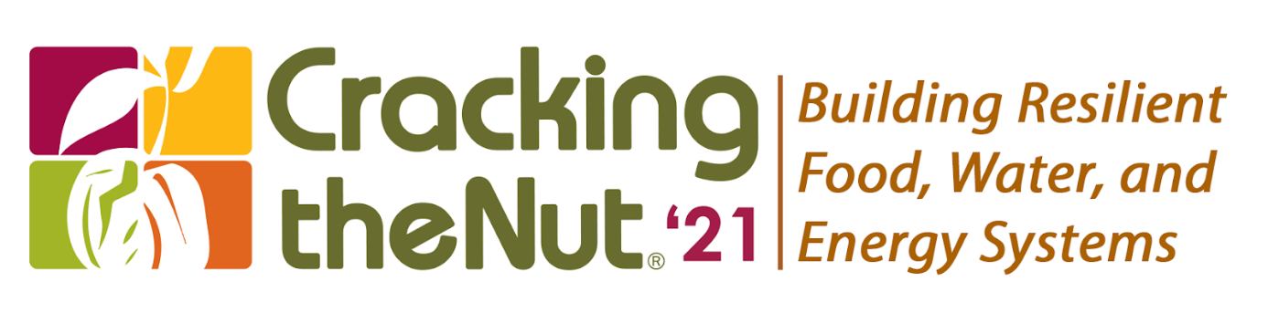
Call for Proposals to Present Explained

The Cracking the Nut® Advisory Committee invites interested persons to submit proposals to present at Cracking the Nut: Building Resilient Food, Water & Energy Systems conference.

The Context
For the first time, the Cracking the Nut® Conference will adopt a fully virtual format due to the COVID-19 pandemic. The 2021 Conference’s primary topic for this year is, “Building Resilient Food, Water & Energy Systems” which is particularly essential today, as the world grapples with a worldwide health and environmental crisis and its impact on vulnerable communities around the world. To improve systems and make them more resilient, we need to mitigate risks, partner collaboratively, and consider the holistic implications of new technologies related to food, water and energy systems and their related support services. This learning event will promote new approaches, innovations and thought leadership that will allow us to find long-term solutions to address growing demands for food, water and energy in developing countries. This conference will facilitate open discussions of the roles of public and private sector, as well as civil society in improving systems, in a way that makes them more resilient, affordable, and adaptable over time. Thus, the conference will bring together development practitioners and relevant stakeholders to discuss innovative ways to support these systems.

This conference’s core themes for the breakout sessions are:

- Applying technology and digital solutions: What technologies and innovative approaches can help to facilitate the building or strengthening of food, water, and energy systems? How can we measure and prove that a system is more resilient? To what extent do these solutions need to be adapted to local cultures and contexts and for remote oversight? How do we scale them up to also be cost-effective?

- Leveraging private sector and multi-stakeholder investments: How can we attract the private sector to participate and invest in food, water and energy systems? What types of platforms are effective in organizing and coordinating multiple stakeholders? How can we mitigate risk and align incentives with market signals? What investment mechanisms and approaches to public financial management are needed to create the infrastructure of a resilient system?

- Ensuring inclusion of vulnerable populations: In designing and adapting systems, how can we ensure participation of women, youth, and disabled populations from being excluded from decision making and benefits? What tools and services can be used to address inequalities and improve access for the rural poor, including for smallholder farmers? How do expanding cities add stress to food, water and energy systems? And what can be done to alleviate that stress?

Instructions and Guidance to Presenters

- GENERAL INSTRUCTIONS

- All proposals should be completed using the Call for Proposals (CFP) form provided and in adherence to the instructions outlined in this CFP. Alternative or noncompliant proposals will not be considered.
- All proposal submissions should be emailed to crackingthenut@connexus.email by Friday, May 14, 2021 with “Cracking the Nut 2021: Proposal to Present” in the subject line.
- All proposals must align with at least one of the conference themes. Presenters may submit more than one proposal to present, but only one presentation per theme will be considered.
- All proposed presenters must have agreed to participate at the time of submission. Participation from female presenters is encouraged.
- Proposals must be written in English.

- EVALUATION AND AWARD

- To ensure full and fair consideration, proposals will be evaluated and selected by the Conference Advisory Committee.
- Selection decisions will be made and all who submitted proposals will be notified of decisions in June 2021.
- Any proposal received in response to this CFP will be reviewed strictly as submitted.
- If selected, you will receive instructions regarding the submission of your presentation materials.
- Selected presentations will be given complimentary conference admission for up to two (2) presenters.

- GUIDANCE ON PRESENTATION FORMAT AND DESIGN

- All sessions are 90 minutes in length and should include at least 30 to 45 minutes for discussion through Q&A, Chat, or live discussion.
- The conference is designed to be a virtual interactive event. We encourage the use of creative and collaborative techniques and formats that engage the audience and promote a participatory learning environment.
- The conference objective is to share and disseminate best practices (including lessons learned and remaining challenges), which are backed by examples, related to one or more of the conference's themes. We also encourage presenters to highlight methodologies that link market mechanisms and allow for private sector engagement.
- While designing the session’s presentation, please keep the following question in mind: "What do you want your peers to get out of the session? How does your session contribute to agricultural development, food security, access to water and energy, secure production of those commodities, systems development, resilience of those systems?"
- The virtual conference will offer various possibilities for presentation to enable maximum interactivity and discussions. Once the presentations are chosen by the Advisory Committee, the CTN technical team will interact with the presenter(s) and guide them on how to use the Socio virtual platform and its available tools, like its Q+A, chat, polling, and breakout room functions.

For additional information regarding conference proposals, please contact us at crackingthenut@connexus.email.
Call for Proposals Form

- Title of proposed session:

- Presenter Information:

 | Name | Title | Organization | Email | Phone Number
1
2
3
4
PLEASE NOTE: All proposed presenters must have agreed to participate at the time of submission. Participation from female presenters is encouraged.

- Name of Collaborating Organization (if applicable):

- Indicate which of the following conference themes your presentation will fall under (Select One):

- Applying technology and digital solutions
- Leveraging private sector and multi-stakeholder investments
- Ensuring inclusion of women, youth, and the rural poor

If your session will have a specific regional focus, please note the region and countries below:

- SESSION DESCRIPTION

- Executive Summary: (Maximum 250 words)
Provide a short description your session, its primary learning objectives and desired outcomes.

- Detailed Session Description and Presentation Method: (Maximum word limit: 350)
Please include information about the session and include an explanation of the format, methodologies and tools used to engage the participants.

- Lessons Learned: (Maximum word limit: 250)
Share examples about the specific features or approaches that worked particularly well, lessons learned and remaining challenges.

- Results and Impact (Maximum word limit: 250)
Please share evidence-based results and the impact created (ideally in system functionality and sustainability, number of people served by the system, impact in terms of increased food, water or energy production, improved health & food security, etc.).

- Biography and Organizational Description (Maximum word limit: 200)
Please provide information about the presenter(s) and the organization for use in the conference program and other promotional materials.

