Integrating Gender and Nutrition within Agricultural Extension Services
Tip Sheets on  Gender-responsive EAS | Adapting to Differing Levels of Education and Literacy
Purpose  To understand how to effectively communicate extension messages to men and women who may have varying levels of education and literacy  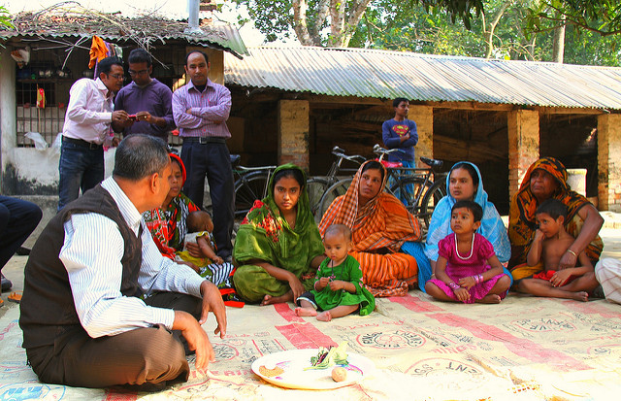 | Why is this important?  Rural women often have less education and lower levels of literacy and numeracy skills than men. Older people are often less literate than younger men and women. Extension and advisory services must account for these differences in all communication efforts. Messages must be conveyed in forms that are suitable for both men and women of all levels of literacy.  Action Steps  Use visual elements in trainings  - Utilize pictures, photographs and diagrams in your training to ensure that your message reaches men and/or women in your audience of all levels of literacy.  - Connect every verbal point with a visual tool, such as pictures or diagrams. This will enable your audience to better remember and recall the content of your trainings.  - Utilize videos to demonstrate key concepts and lessons.  Use participatory approaches such as role play, simulations or experimental games while conducting trainings  - Role play, simulations and experimental games are very effective ways of communicating critical lessons to audiences of all levels of literacy and education.  - Make a checklist of all the items you will need for the activity.  - Demonstrate the activity with multiple volunteers before doing it with your audience.  - Always use everyday life circumstances that are customized to your audiences’ experiences. This will make your message applicable.  - Conduct group discussions following participatory activities. Group discussions will enable participants to reflect on the activity, think about the lessons learned, and come up with practical applications for their lives.  3. Use ICTs effectively in your services  The rise in the use of Information and Communication (ICTs) can help to extend the reach of extension services to remote locations and communicate messages in formats which do not require literacy like brochures. It is can be easier to reach farmers with extension messaging through audio (such as radio, voice calling on mobile) or visual-video (TVs, computers) methods. However, in many places women do not have equal access to ICTs. Differences in men’s and women’s access to ICT should be taken into consideration. Before choosing to use ICTs:  - Ensure that women in your area of service have access to ICTs such as mobile phones and radios.  - Understand if women have control of its use and/ or ownership. For example: A household may have a mobile phone, but a woman may not be allowed to use it without the presence of or consent from her husband. Develop strategies for overcoming such barriers.  - Take into account whether all clients, including women, have the financial resources to pay for the use of ICT – the device, electricity to run it, and service or subscription fees.  - Determine if women have adequate knowledge and skills on how to use the technology. If not, plan to help them develop that ability.
Good Practice Examples
There are some great examples of how extension techniques and information have been adapted to reach both men and women farmers despite barriers in literacy.
- In Mozambique, the International Potato Center used colors instead of words to allow men and women to indicate preferences among sweet potato varieties.
- In Ghana, The Sustainable Tree Crops program delivers training to farmers through video viewing clubs. In this method, illiterate and low-literate women farmers watch videos that are 10-15 minutes in length on a range of topics such as integrated crop and pest management, which is then followed by a discussion. They have women’s clubs and mixed-sex clubs which have both men and women participants.

- In Uganda, the Women of Uganda Network (WOUGNET) gives women’s groups a mobile phone and a radio or cassette player to listen to local agricultural radio shows, call extension officers or share information between groups. WOUGNET was successful because it worked within channels that were already familiar to women farmers (such as radio and extension officers) and worked through informal channels (women farmers sharing information between groups).

- The Community Knowledge Worker (CKW) program being implemented by the Grameen Foundation in Uganda is exploring ways of delivering agricultural information through cell phone voice commands and call centers to allow women and men with lower literacy levels to become CKWs.

References and Resources
Manfre, C., Rubin, D., Allen, A., Summerfield, G., Colverson, K., & Akeredolu, M. (2013). Reducing the gender gap in agricultural extension and advisory services: How to find the best fit for men and women farmers. MEAS Discussion Paper 2. www.meas-extension.org/meas-offers/best-practice
Meinzen-Dick, R (2016). Games for Sustainability http://gamesforsustainability.org/
Viswanathan, M. (2013). Subsistence Marketplaces. www.business.illinois.edu/subsistence/research/publications/subsistence-marketplaces-ebook
Viswanathan, M. et al. (2009). Literacy and Consumer Memory. Journal of Consumer Psychology, 19, 389–402. www.business.illinois.edu/subsistence/research/publications.html
Photo Credits
Page 1: © Andrea Bohn, Bangladesh, December 2012

