The breeding pipeline begins to flow

From our first wave of phenotyping 1083 lines (using populations generated under CGIAR-GCP support and continued by us), 14 lines were evaluated through participatory selection, leading to the identification of one line, Sambola, which has been released to farmers in Mali (picture below). The grain yield increase of this line was over 50% higher than the recurrent parent Lata in high input conditions as well as in low input ones. Another sister line named Samboni has been also identified by farmers and will be proposed for release in 2018. Phenotyping of more than 2500 additional lines that based on crosses that were tailored to our goals remains in progress in Mali and Ethiopia.

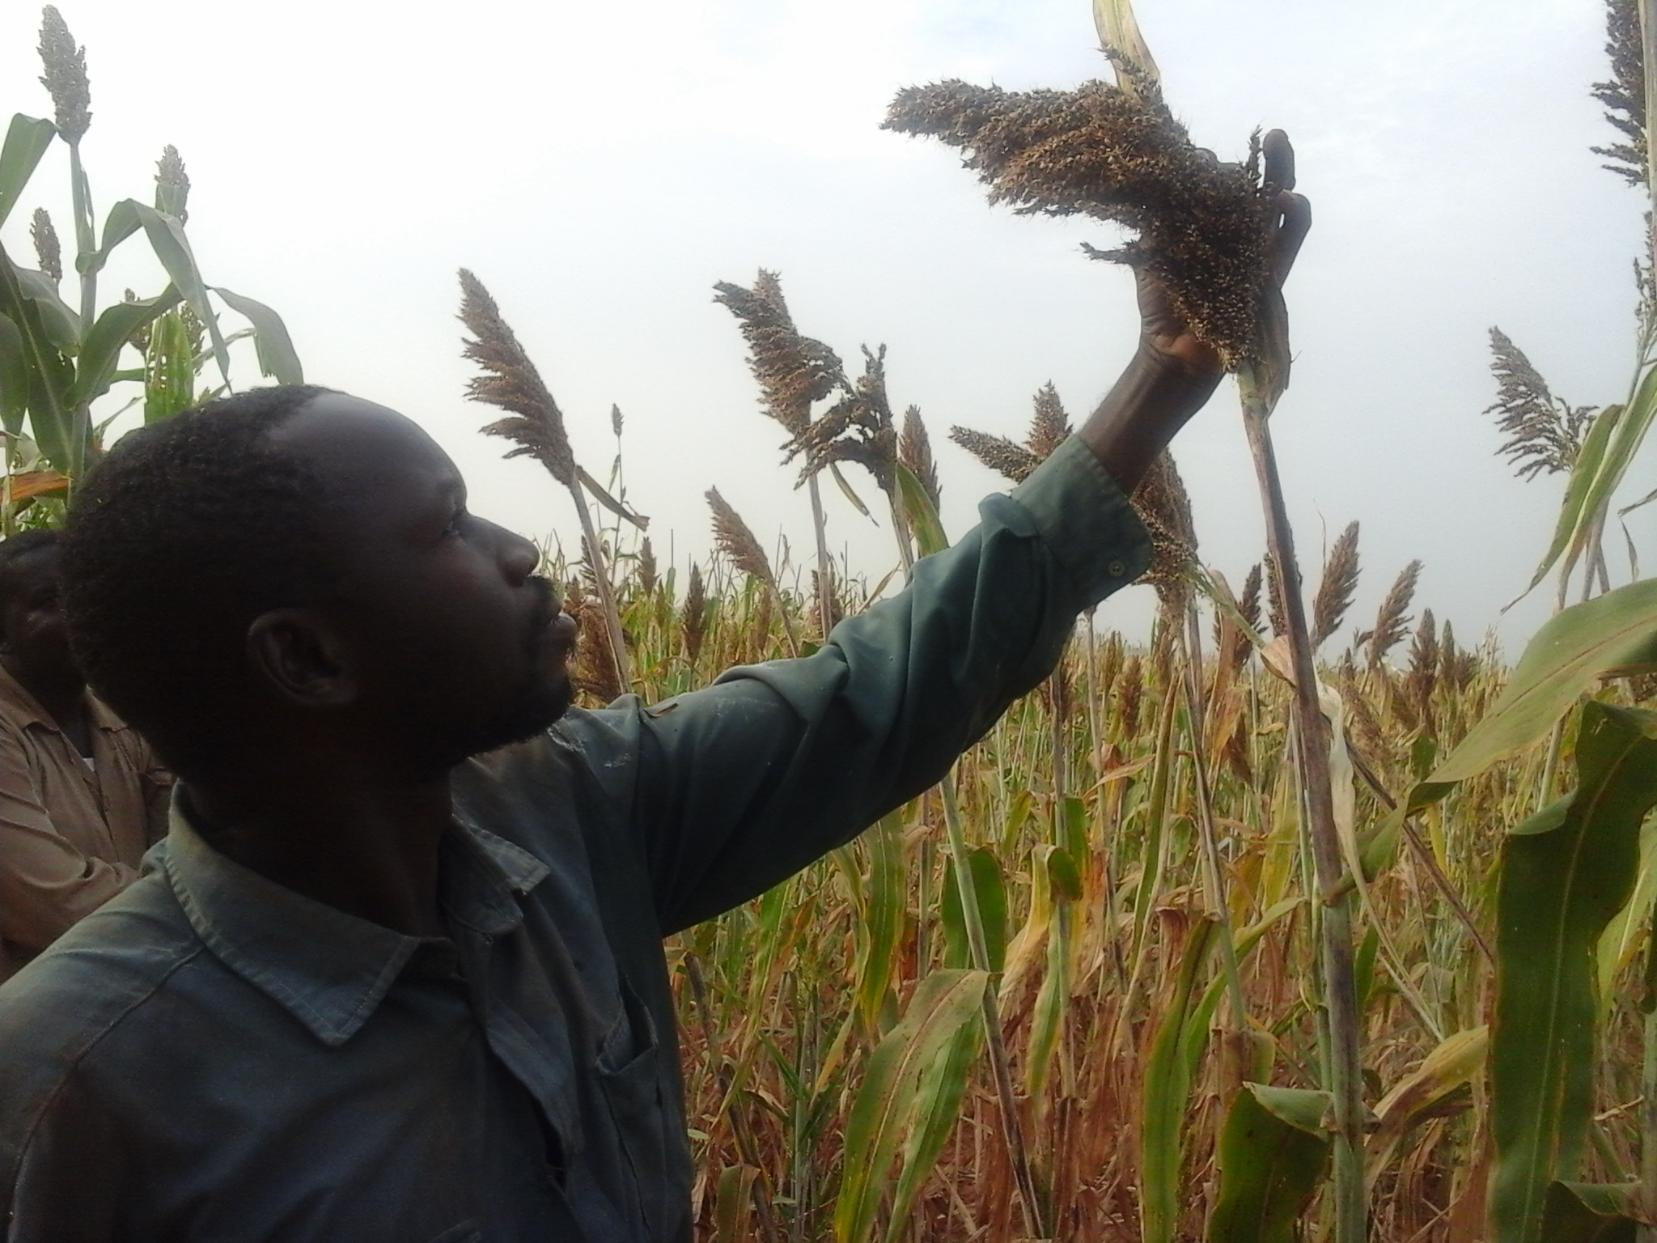
Striking yield improvement from wild sorghum relatives

Building on the demonstration that our quasi-perennial germplasm can survive a tropical dry season to regrow, ratooning and perenniality-related traits have been substantially recapitulated in African germplasm and environments. A serendipitous finding was that 15 F1 hybrids with S. bicolor x S. propinquum RILs yielded more (up to 22%) than the highest yielding parent (BTx623) – indeed, crosses to ‘RIL 234’ increased hybrid yield in F1 combinations with all 4 testers (photo below).

A breakthrough toward breeding perennial sorghums

A major hindrance to breeding perennial sorghums has been a ploidy barrier between sorghum (2x) and the primary source of perenniality, S. halepense (4x). Recently, T. S. Cox has identified S. halepense x S. bicolor lines that showed phenotypes and segregation patterns consistent with diploidy, exhibiting much more ‘sorghum-like’ phenotypes and seed quality while also segregating for S. halepense traits (photo below). Chromosome counts confirmed many of these lines to be diploids, and SSR genotyping confirmed their hybridity, showing that most regions of the S. halepense genome could be sampled in these lines (although not all in the same line). A manuscript describing this phenomenon is in press at the refereed journal ‘Genetic Resources and Crop Evolution’ (Cox et al 2017). The availability of S. halepense traits (genes) at the diploid level promises much more effective incorporation into conventional sorghum germplasm, and evaluation of the merit(s) of these traits.

Typical hybrids between diploid Sorghum bicolor and tetraploid perennial sorghum parents (derived from S. bicolor / S. halepense crosses.) Left: a typical tetraploid F1 plant and panicles from a typical F4:5 derived line. Right: one of more than 100 unexpected diploid F1 plants and panicles from a diploid F2 population. F1 plants of both ploidies are normally tall (2-3m) and produce brown seed. Diploid segregating populations, unlike tetraploids, exhibit wide variation for height and seed color as early as the F2 generation. Diploid progeny tend to exhibit less tillering and branching, thicker culms, larger seed, and smaller, less tenacious glumes than are seen in tetraploid populations.

